Report No: 4001
U.S Coast Guard Academy
Introduction to Mechanical Design (1208)
2022
Team 4: Bilge Pump

Bilge Pump

Author: Moustafa Mahmoud Sabra ________________________
Checked: 3/c Kevin Hall ________________________
Issue Date: 04/27/2022
Electronic Folder: IMED Spring 2022\Documents\General\Lab Material

Abstract
Assembling the bilge pump requires minimal tools or experience and can be completed by splitting the pump into a few fundamental pieces. The assembly processes can be broken into the pump body assembly, the handle assembly, the mechatronics circuit assembly, and eventually the final product assembly. The exact steps are detailed in this report.

Acknowledgment
It is essential to acknowledge that the completion of the prototype would not have been possible without the supervision of CDR Ryan Angelo and Dr. Richard Freeman. In addition, a special thanks should be issued to the managing staff of the United States Coast Guard Academy Power Lab for their contributions toward the fabrication and assembly of the pump body parts and final product.

Table of Contents
Abstract 2
Acknowledgment 2
Chapter 1: Introduction 4
Chapter 2: Assembly of Each Section 6
2.1 The Bump Body Assembly 6
2.2 The Pump Manual Handle Assembly: 6
2.3 The Mechatronics circuit: 7
Chapter 3: Recommendations and conclusions: 8

Table of Figures
Figure 1 Assembled pump with hand crank 5
Figure 2 Assembled pump with motor and Arduino 6
Figure 3 Top and side views of the pump body 7
Figure 4 Crank and Connecting Rod assembly 8
Figure 5 Arduino wiring and motor attachment 9

Chapter 1: Introduction

The parts manufactured using machines in the Power Lab include the pump body, support arm, axle, connecting rod, crank arm, crank disc, piston, and handle.

Additional parts were used to enable the mechanics and connections between the main parts mentioned previously, containing the NPT barbed fitting, ball bearings, and set screws with appropriate sizes that match the design parameters.

An Arduino-based circuit was constructed to control the rotation of the pump motor and piston. An EGLEGOO Mega R3, Arduino Motor Shield, motor driver, breadboard, power supply, jumpers, and water level sensor were used to construct the monitoring circuit.

The final prototype comes with two configurations, either a manual-based drive or a mechatronic-based drive. The manual drive relies on the user exerting force manually to turn the crank disk, while the mechatronic-based version utilizes a DC motor for rotating the crank disk.
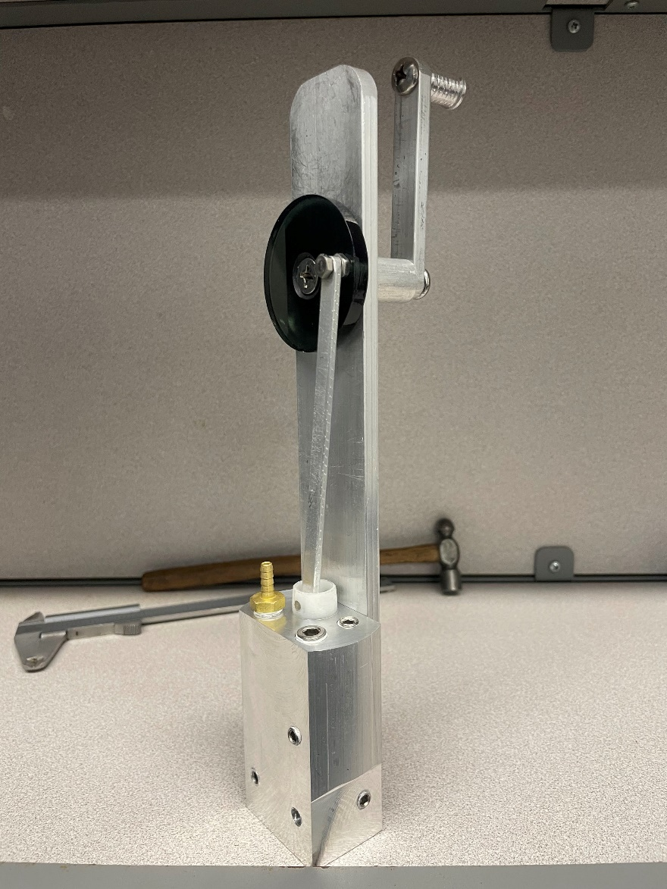
Support Arm
1/8 NPT Barbed Fitting
5/16 inch Set Screw
7/16 inch Set Screw
Piston
1/4 inch Set Screw
1/4 inch Set Screw

Axel
Crank Rod
Handle
Pump Body
Connecting Rod
Crank Disc
Figure 1 Assembled pump with hand crank

The project’s parts are labeled in Figure 1 above and the final prototype is shown in Figure 2.

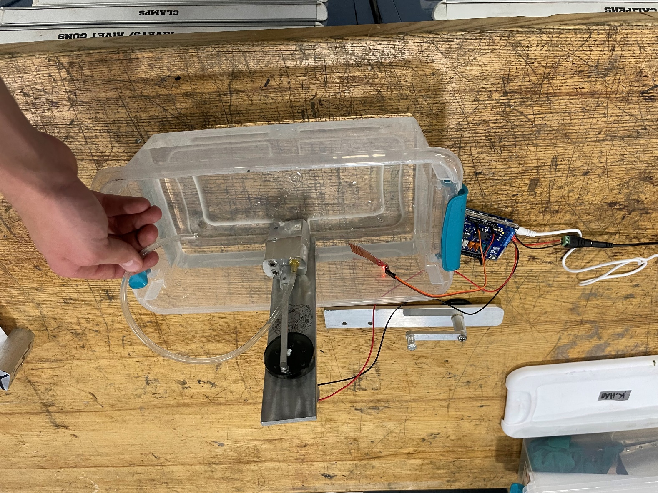
Figure 2 Assembled pump with motor and Arduino
The following general procedure was used to build both prototypes:
Manual-based mechanical drive
- Screw the pump body to the front side of the support arm
- Attach the handle piece to the backside of the support arm
- Place the crank disk on the front side of the handle
- Screw the disk to the handle
- Connect the connecting rod to the piston
- Screw the connecting rod to the crank disk

Mechatronics-based drive more
- Screw the pump body to motor support arm
- Align the DC motor in the top center hole of the backplate
- Screw the DC motor to the support arm
- Attach the crank disk to the motors shaft
- Connect the connecting rod to the piston
- Screw the connecting rod to the crank disk
- Connect the DC motor to the Arduino circuit

Chapter 2: Assembly of Each Section

2.1 The Pump Body Assembly

Figure 3 below shows the configuration of the pump body, barbed fitting, and set screws. One 5/16 ball bearing was placed inside the holes beneath the barbed fitting and 7/16 inch set screw. The barbed fitting was screwed to its assigned location on the lower left hole on the body’s top side. Five set screws fitted with Teflon tape were then placed to cover all of the holes besides the intake in the front side of the body.

Figure 3 Top and side views of the pump body

2.2 The Pump Manual Handle Assembly:

The handle piece was designed to give the user a means to exert mechanical force to rotate the crank disk. Figure 4 shows the final version of the handle connected to the supporting arm. After the pump body is connected to the backplate, the axle is positioned in the top hole of the backplate. On the side holding the pump body, the crank disk is fitted to the smaller end of the axle. On the other side, the crank arm is connected to the back of the axle. Finally, the handle cylindrical piece is screwed to the other end of the crank rod.

Figure 4 Crank and Connecting Rod assembly

2.3 The Mechatronics circuit:

A simple Arduino circuit was designed to automate the pump based on the presence of water. Jumpers, an Arduino board, a water-level sensor, and a motor shield were the main components of the circuit. The motor shield is attached to the EGLEGOO board in the assigned power and ground pins as shown in Figure 5. A pair of jumpers extends from the Motor Shield terminals to the power and ground connections of the DC motor and power supply as shown in Figure 6. The liquid-level sensor is connected to the Arduino pins GND, A2, and 3.3V to activate the pulse width modulation script loaded on the Arduino board to read and interpret water-level measurements. The water level sensor is then programmed using the Arduino IDE in C to activate the pump once the water level is below a certain threshold. Eventually, the power supply is connected to the Motor Shield’s power and ground pins using a pair of jumpers to supply the circuit with 12 V. The shield will make sure to only supply the other parts of the circuit their capacity with no additional load, allowing an even distribution of power through the circuit. Since the DC motor needs more power, it takes 12 V from the shield while only a maximum of 5 V is supplied from or to the Arduino board.
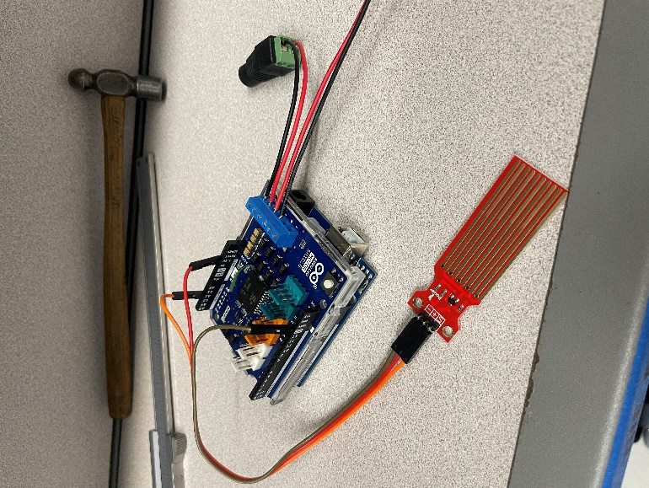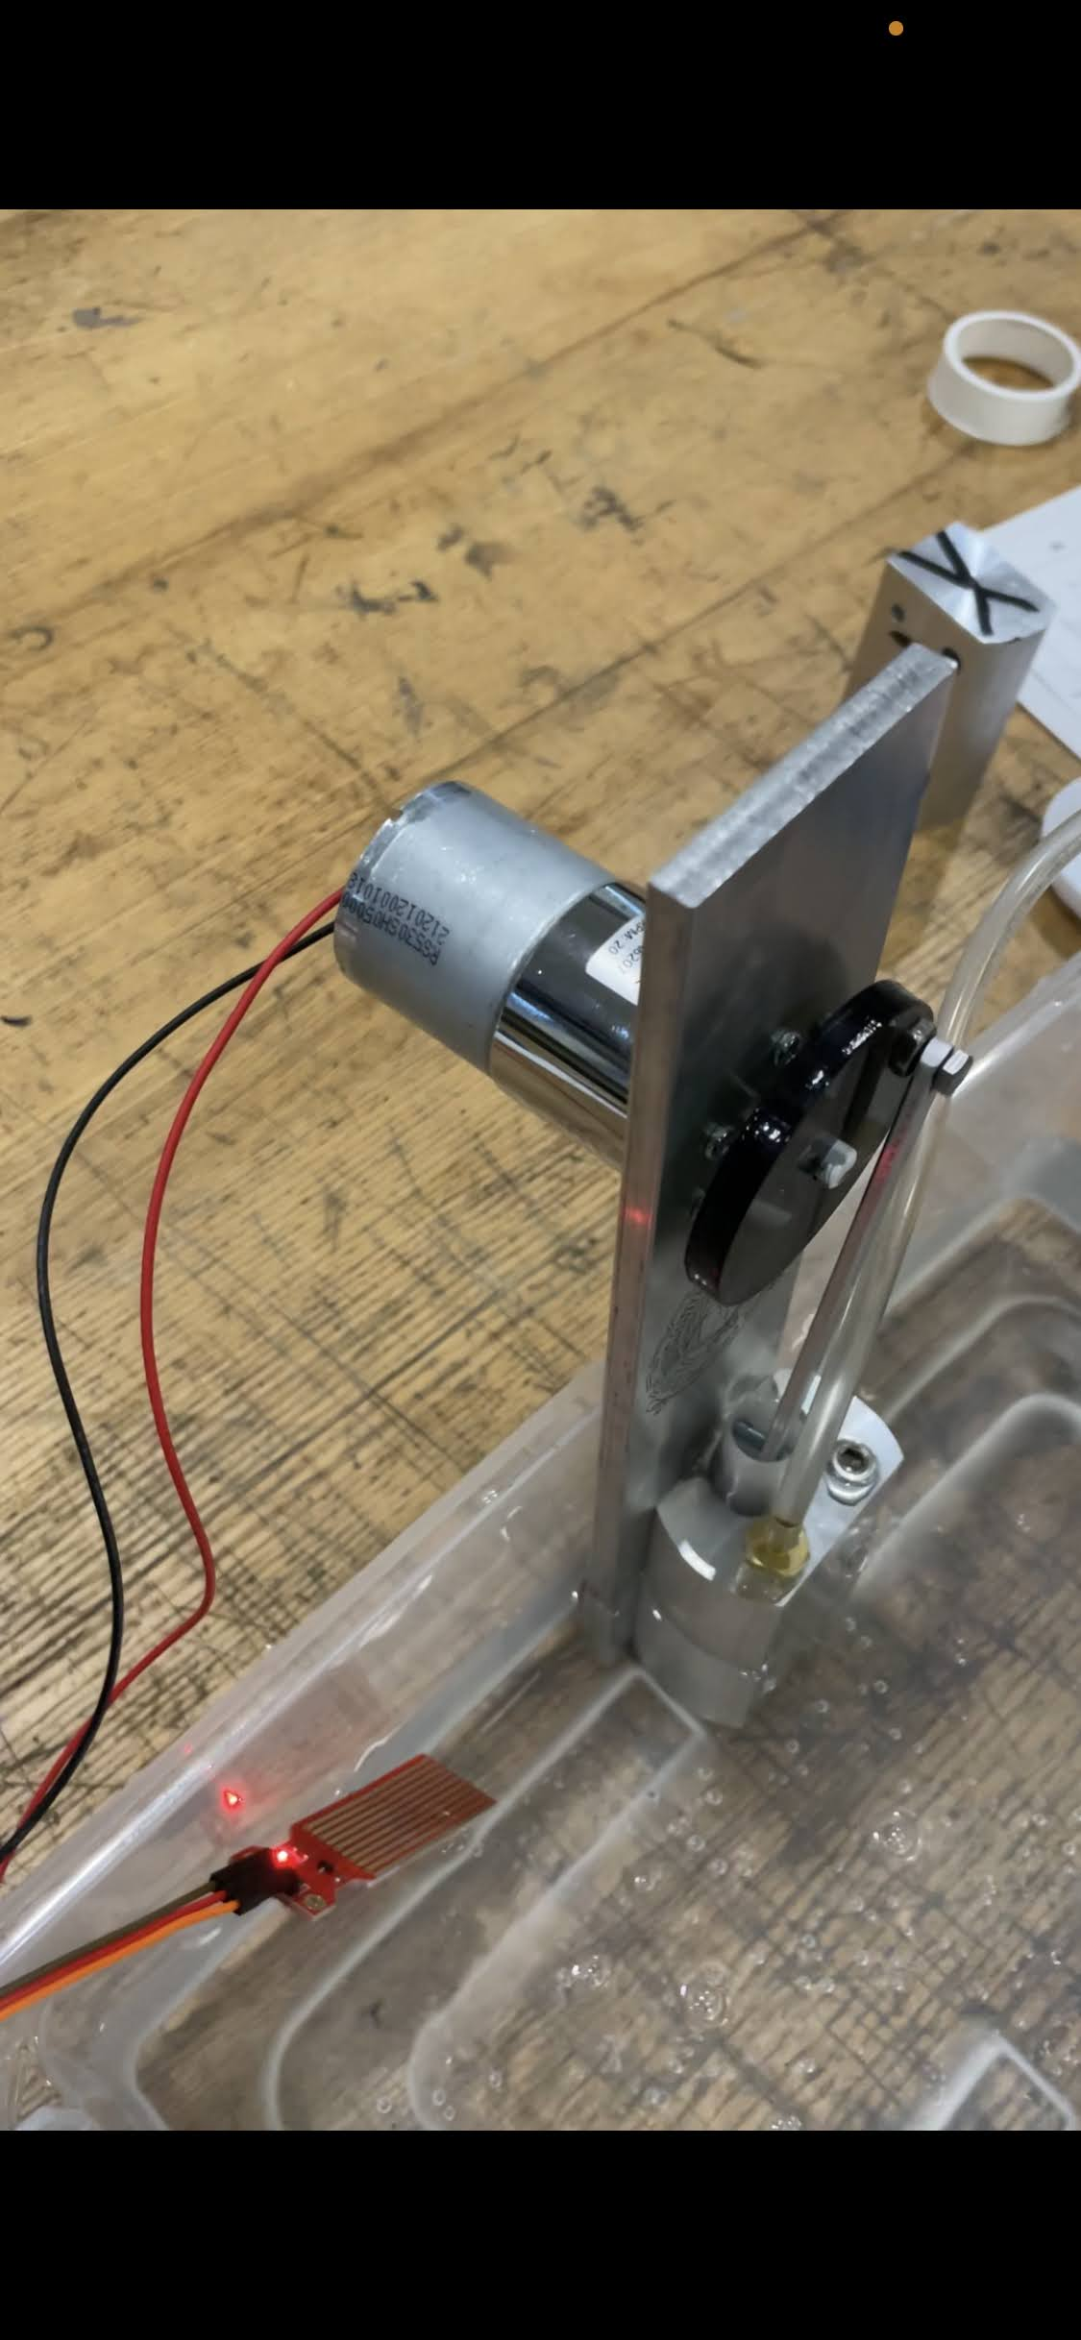
Figure 5 Arduino wiring and motor attachment

Chapter 3: Recommendations and conclusions:

Many changes to the design of the bump body could be applied if it were re-built. Various assembly issues were faced such as accurately estimating the amount of material to sand off of the piston sides to achieve the required suction. Additional issues arise when implementing the mechatronics-based drive mode, as it is usually hard to fit the Arduino in a place where its motion doesn’t interfere with the motor or the water level sensor

